Chapter 4-[Number Theory](https://mfleck.cs.illinois.edu/building-blocks/version-1.3/number-theory.pdf)

Wednesday, December 28, 2022

1:27 AM

***Number Theory:***

Divisibility:

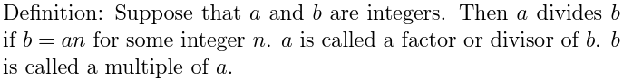



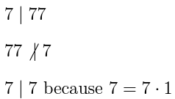



***Proof with divisibility:***

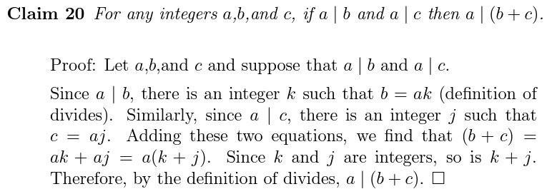

*Try to keep proofs using only integers, construct math from the ground up, this helps prevent errors.*

*Notice that k | (a - b) if and only if k | (b - a).*

**Fundamental Theorem of Arithmetic**: Every integer 2 can be written as the product of one or more prime factors. Except for the order in which you write the factors, this prime factorization is unique.

For example, 260 = 2*2*5*13 and 180 = 2*2*3*3*5.

Zero is neither prime nor composite, there **infinitely many** ways to factor 0.

**Formula for Least Common Multiple (lcm):**

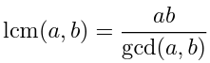

Where gcd is the Greatest Common Divisor function.

(use the *Euclidean Algorithm*, or manually inspect two numbers' prime factorizations and extract shared factors to find gcd)

When two integers a and b share no common factors, then gcd(a,b) = 1. The two integers are called **Relatively Prime**.

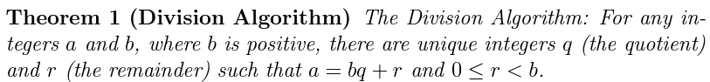

**Remainder is required to be non-negative!**

*So -10 divided by 7 has the remainder 4, because -10 = 7*(-2)+ 4.*

*(don't be like me and forget how to do basic division)*

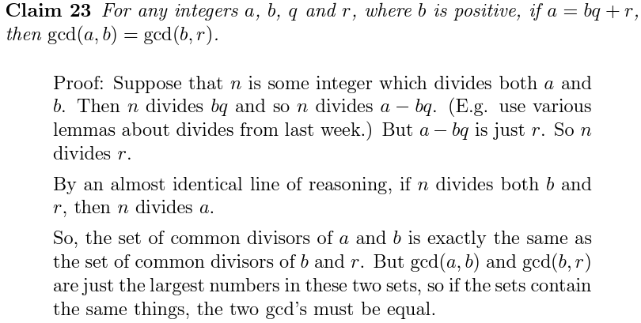

*(to prove the 2 have the same common divisors, we just need to prove that given x|a and x|b, we can get x|r and x|b (and vice versa), so the two sets are the same)*

**Corollary** means that a fact is a really easy consequence of a previous claim.

*(in the above case, concluding that gcd(a,b) and gcd(b,r) are the same from the proven claim-the set of common divisors of (a,b) is the exact same as the set of common divisors of (b,r)-is a corollary)*

In *Modular Arithmetic*, there are only a finite set of numbers, addition “wraps around” from the highest number to the lowest one.

***Congruence Mod K:***

Two integers are “congruent mod k” if they differ by a multiple of k.

Formal Definition:



*Examples:*

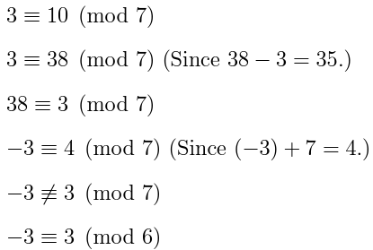

***Modular Arithmetic Proof:***

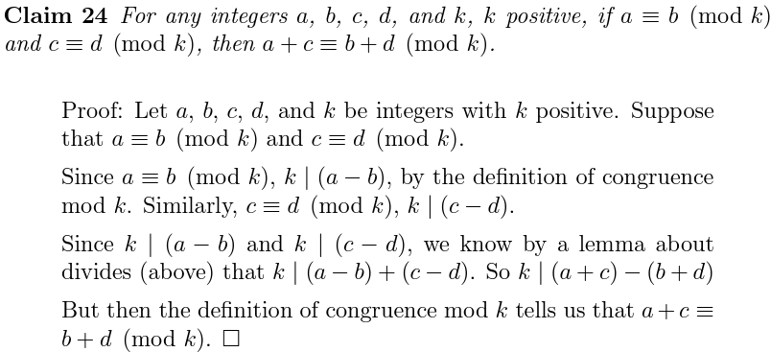

***Congruence Class/Equivalence Class:***

The equivalence class of x (written [x]) is the set of all integers congruent to x mod k. (with k being fixed and x being the variable)

For example, if k is fixed to be 7,

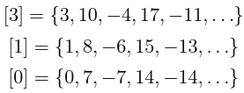

Modular Congruence Rules:

